# InternSpark Java Developer Internship

## Task 2: Demonstrating OOP Concepts in Java

### Objective

The objective of this task is to create a Java class that demonstrates fundamental Object-Oriented Programming concepts such as classes, objects, constructors, methods, and encapsulation.

### OOP Concepts Demonstrated

1. **Class** – A blueprint used to define the properties and behavior of a student.
2. **Object** – An instance of the Student class.
3. **Constructor** – Used to initialize student information when an object is created.
4. **Methods** – Used to define the behavior of the Student object.
5. **Encapsulation** – Student data members are declared private.

### Source Code

```java
class Student {

private String name;
private int age;
private String course;

public Student(String name, int age, String course) {
this.name = name;
this.age = age;
this.course = course;
}

public void displayDetails() {
System.out.println("----- Student Details -----");
System.out.println("Name : " + name);
System.out.println("Age : " + age);
System.out.println("Course : " + course);
}

public void study() {
System.out.println(name + " is studying " + course + ".");
}

public static void main(String[] args) {

Student student = new Student(
"Sachin",
21,
"B.Tech Computer Science"
);

student.displayDetails();
student.study();
}
}
```

### How to Run

```bash
javac Student.java
java Student
```

### Sample Output

```text
----- Student Details -----
Name : Sachin
Age : 21
Course : B.Tech Computer Science
Sachin is studying B.Tech Computer Science.
```

### Screenshot
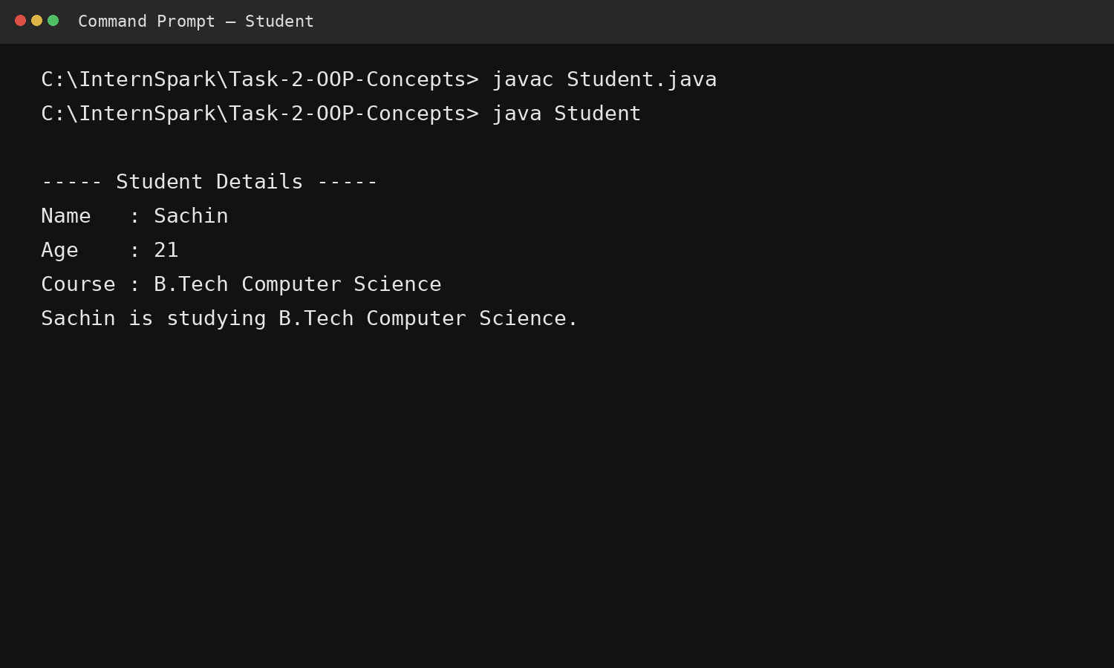
### GitHub Repository

`[YOUR GITHUB LINK]`

### Conclusion

This task demonstrates how Java uses object-oriented programming to organize data and behavior using classes and objects. The implementation also demonstrates constructors, methods, and encapsulation.

